**PID temperature controller and relay controller**

The program controls temperature of the main heater and measures the line voltage to shut down the boiler in case of electricity outage in the lab.

**Run the controller**: Documents\PID_Temp\RUN_PID.bat

1. When the controller starts it asks for VISA resource name of Keithley instrument. In our case it is GPIB::16::INSTR

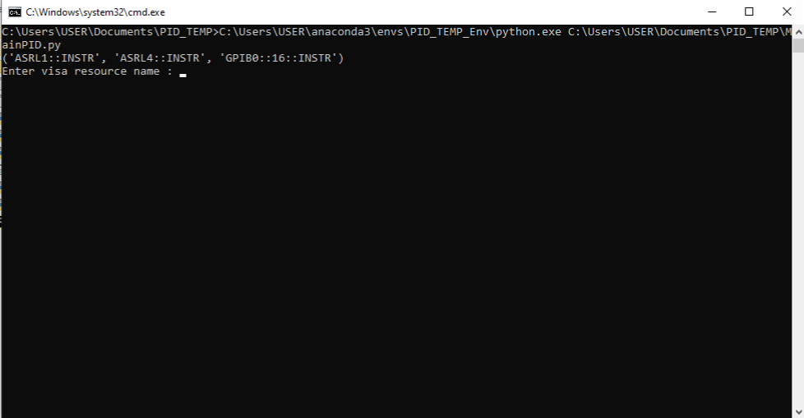

1. After the controller connects to Keithley it asks to enter the heating mode: Temperature gradient mode (T) or constant power (P). In most cases constant power can be chosen.
2. Next step – enter temperature setpoint (in Celsius)
3. If constant power mode is set, enter heat-up power level (%). To reach 450C usually 80% power is enough.
4. The controller connects to Arduino and turns ON the secondary relay. The heating starts.
5. Controller shows temperature of the main heater after each measurement iteration.
6. Red LED blinking shows control signal to the main heater relay. Yellow LED shows the state of the secondary relay. White LED shows power in the power line.
7. Each 15 iterations of temperature measurement the controller also measures the voltage in the main power line. If it is below the threshold, controller stops and turns off the main heater relay and secondary relay.
8. To stop the controller press and hold SPACE button until “Chose mode: E - exit, P - PID-control, I – initialization” appears. Delete excessive spaces and type (E).
9. Settings are kept in “basic.ini” file in the controller’s folder.
10. The first section contains PID settings.
11. The second section contains settings of Arduino: port – serial port number, d_channel – Arduino’s digital channel number for the main heater control, aux_channel – digital port number for the secondary relay control, analog_channel – analog channel number to measure line voltage
12. The third section contains settings of line voltage measurement:

power_check_counter – number of temperature measurement iterations after which the line voltage is measured

line_voltage_threshold – relative threshold (in Arduino counts) of the line voltage.